**Methodology Airbnb**

* **Objective:** 
  + - To understand customer preferences and user experience trends.
    - To build strategies for reviving the Airbnb NYC business post-covid.
* **Exploratory Data Analysis:** 
  + - Checked the Null values in the dataset. Found some columns with the null values i.e., names, host_name, last_review, and review_per_month.
* **Data Assumptions:**
  + - We assumed that prior to the restrictions the company was achieving desired revenue.
    - The next steps for reviving the business are based on the assumptions that travel would increase once restrictions are lifted.
    - The dataset is assumed to be free of outliers.
* **Data Analysis:**
  + - The data analysis was performed in Tableau software. The CSV file once uploaded in Tableau has 49k records.
    - The columns in the dataset were self -explanatory. Refer to the following diagram to get a better idea of what each column signifies.

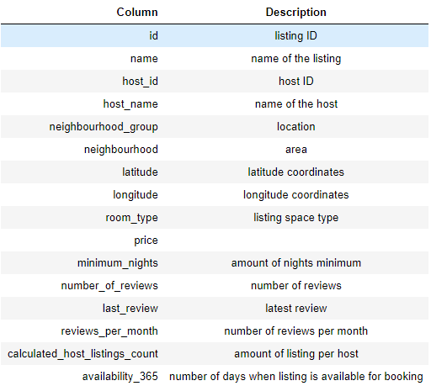 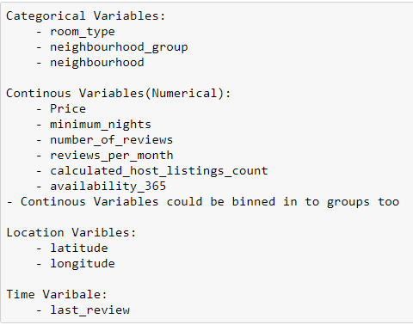

* The idea is to dive deep into Hosts and Host listings and slice and dice them by various dimensions like neighborhood, price ranges, accommodation types, availability and customer reviews.
* Univariate and bi-variate analysis was performed on different columns in tableau such as on the basis of price, availibity_365,minimum_nights, room type etc.
* **Insights from Analysis:**
* Hosts and listing’s overall view. We have over 37K hosts and they have around 350K listings on the platform in the New York region. On average, each host has around 9 listings across multiple categories and locations.

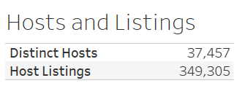

* Most of the host listings are from Manhattan location(almost 79%) followed by Brooklyn(13%).

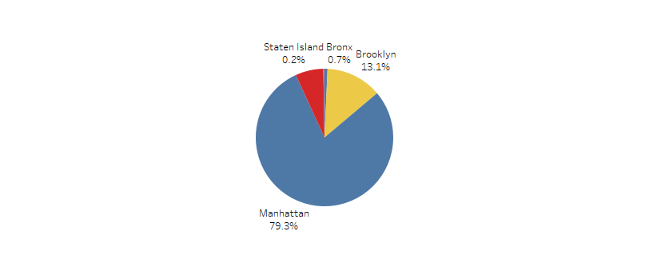

* Most of the Hosts either belonged to Manhattan or Brooklyn as can be seen from the following figure. Also, an interesting insight is that Hosts with most listings are not the ones with most reviews.

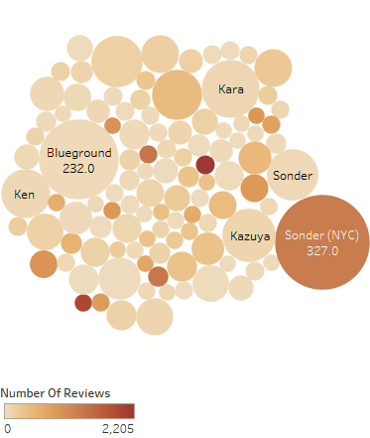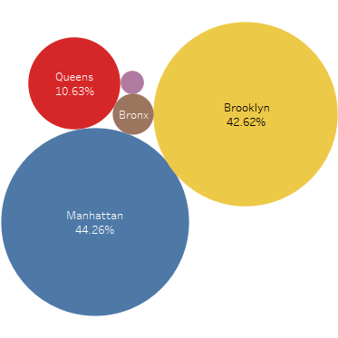

* Target **premium properties in Bronx** as they are least expensive and have highest average reviews.
* The properties in Manhattan are the most expensive while in Bronx are the least expensive.

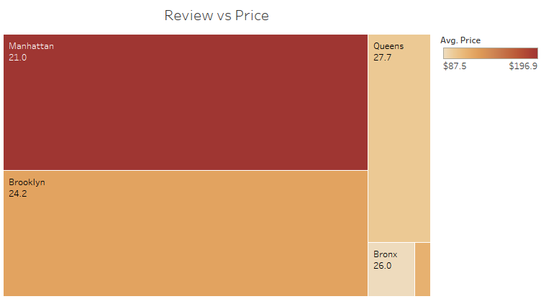

* Customers preferred **Entire home/apt** and **private rooms** over shared rooms listed in the Airbnb NYC.
* 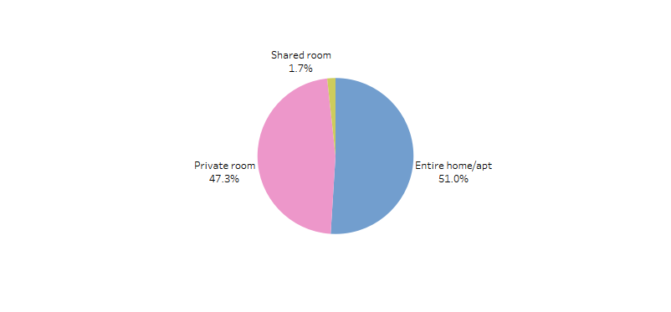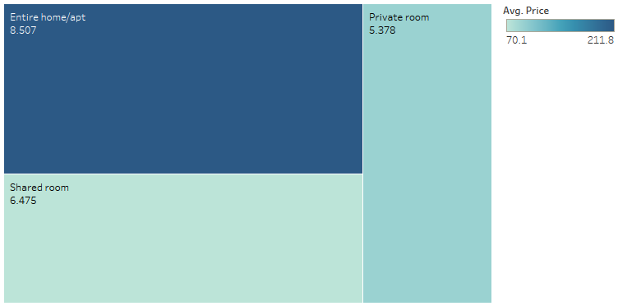Private rooms have lesser average of Minimum Nights as compared to Shared rooms; thus, this can be preferred more by the customers.
* Since hosts that offer a minimum night stay are the most reviewed hosts. So, target hosts offering least minimum night stay. Most of these hosts either own Private room or Shared rooms.

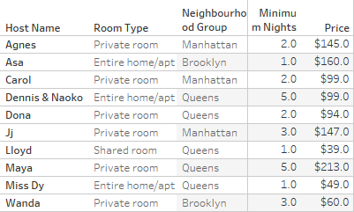

* Manhattan is the most expensive location and Bronx is the least expensive location. This might be because Manhattan is prime location.
* But the most expensive areas Fort Wadsworth and Woodrow are from Staten Island Location
* Bulls’ Head (Staten Island) and Hunts Point (Bronx) are least expensive areas.

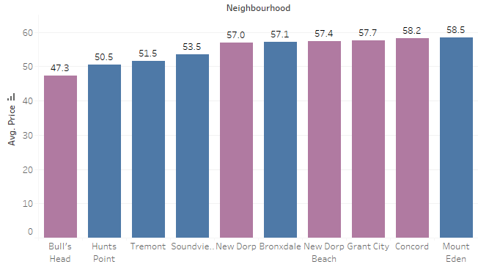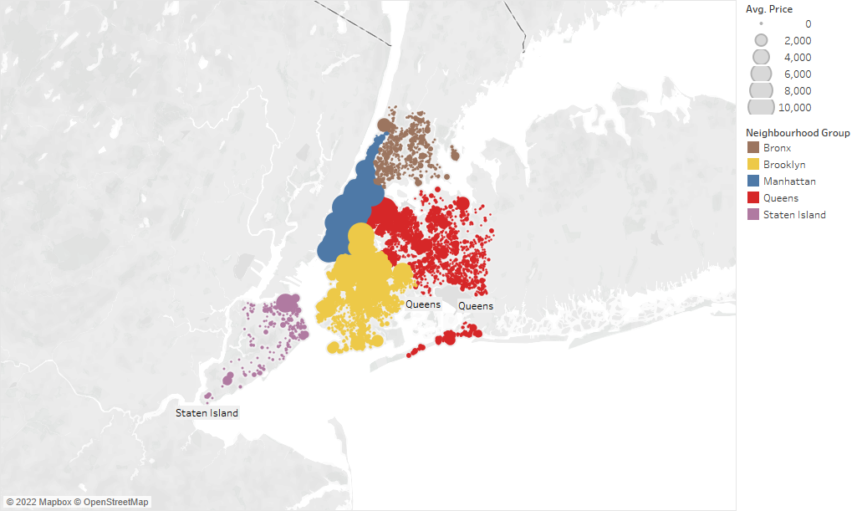

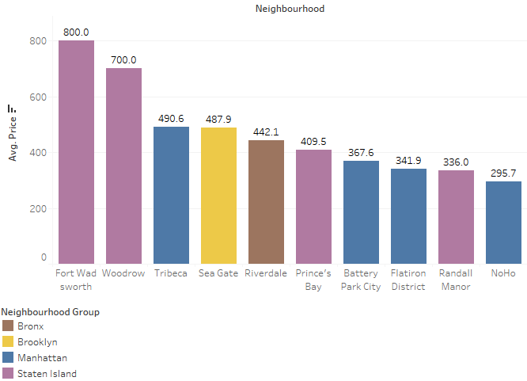

* Shared rooms are most available, since they are least preferred by the customers.

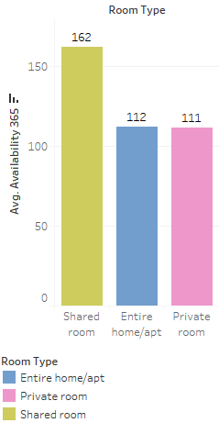

With the help of above analysis and visualizations , we tried to find insights that would influence the next steps for Airbnb business .We did this by inquiring about the answers of following questions :

* Which type of hosts to acquire more and where?
* The categorisation of customers based on their preferences.
* What are the neighbourhoods they need to target?
* What are the pricing ranges preferred by customers?
* The various kinds of properties that exist w.r.t. customer preferences.
* Adjustments in the existing properties to make it more customer-oriented.
* What are the most popular localities and properties in New York currently?
* How to get unpopular properties more traction? and so on...